Introduction to GIT and GitHub

**Student ID**: 102721594

**Full Name**: Harrison Lim

# Resources

1. <https://help.github.com/articles/creating-a-new-repository>
2. <https://git-scm.com/doc> / <https://git-scm.com/downloads>
3. <https://github.github.com/training-kit/downloads/github-git-cheat-sheet.pdf>

# Tasks

1. If you do not already have a GitHub account, sign up with your student email address here: <https://github.com/join>
   1. If you live for free stuff, after signing up enter your details here: <https://education.github.com/pack/join>
2. Create a new Public Repository named “ICTPRG-Python”
3. Clone the Repository with Git for Windows
4. Add all your existing code into the repository folder
5. 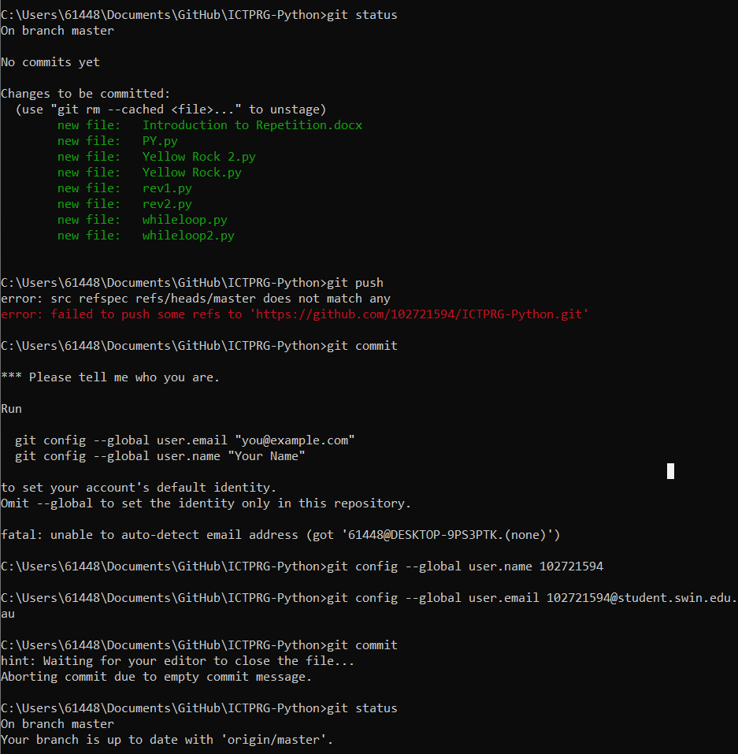Take a screenshot of the git status command and paste it below.
6. 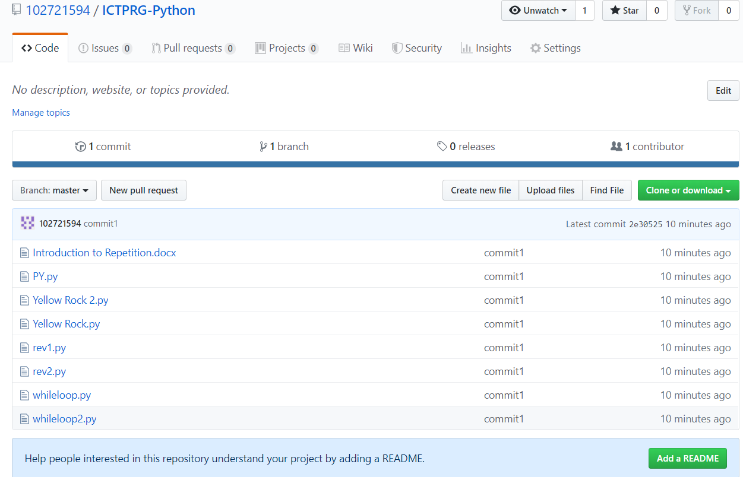Commit and push your changes. Refresh GitHub and attach a screenshot of the Repository below.
7. Paste the URL to your Repository below.

<https://github.com/102721594/ICTPRG-Python>